
DHARMSINH DESAI UNIVERSITY, NADIAD
FACULTY OF MANAGEMENT AND INFORMATION SCIENCE
B.C.A. SEMESTER VI
SUBJECT: (25BCA601)SYSTEM DEVELOPMENT PROJECT
Student Name | Himanshu D Ladha
Roll No | BCA045
Student ID | 23BCUOS055

Project Definition: RestoFlow – A full-stack Restaurant Management Platform.

Company Timing: 11:00 AM to 6:00 PM

Week | Date | Day | Name of the Topic | Signature
Eighth Week | 19-01-2026 | Monday | Order flow improvement
Eighth Week | 20-01-2026 | Tuesday | Reservation System Implementation
Eighth Week | 21-01-2026 | Wednesday | Continue with the backend more
Eighth Week | 22-01-2026 | Thursday | Design the frontend for restaurant admin side
Eighth Week | 23-01-2026 | Friday | Check and manage for the customer side.

External Guide Name: Somil Sir Internal Guide Name: Prof. Rupal Patel
Signature Signature

19-01-2026
- When an order is completed with payment, an issue occurs during the second order where the payment transaction occurs multiple time.
- To resolve this, I added a feature that allows users to add items and place an order, after which they are prompted with an option: “Do you want to order more items?” (Yes / No).
- If the user selects No, the Pay Now option is displayed immediately.
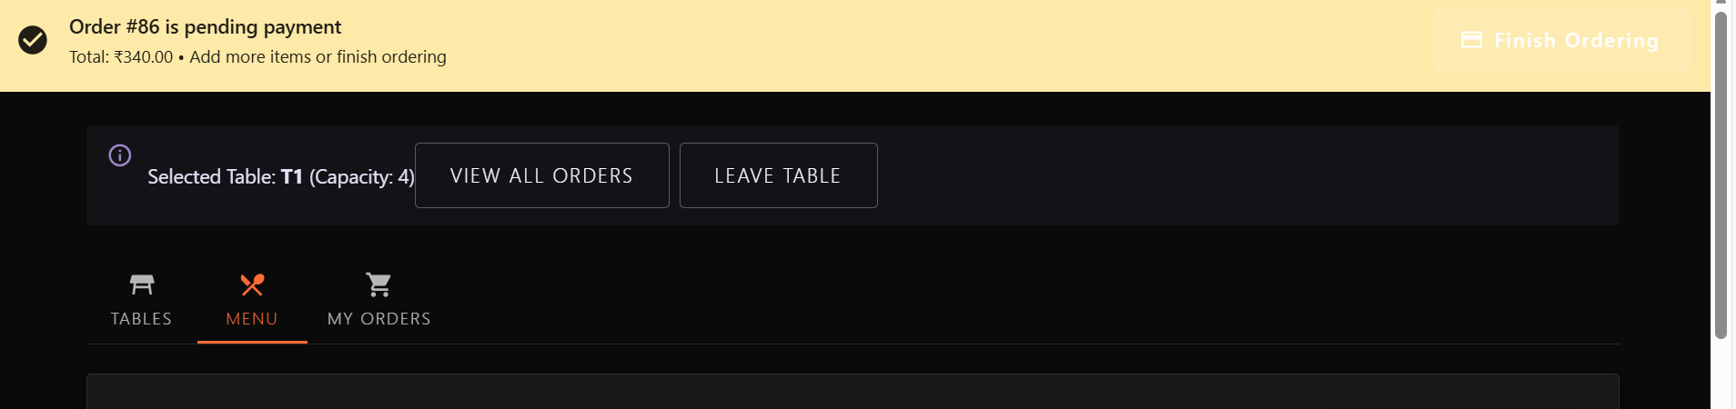
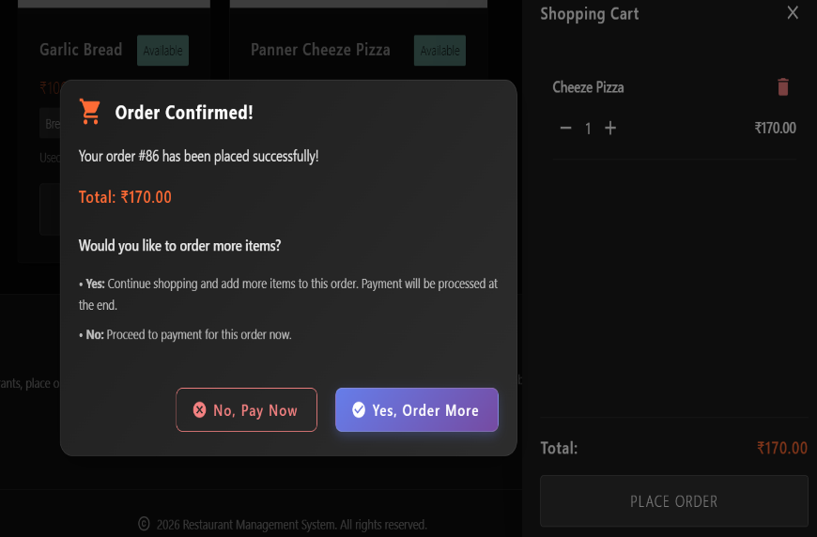
- If the user selects Yes, they can add more items or place another order. A Finish Order button is then shown, and once the order is completed, the payment option appears and the payment can be made successfully.

20-01-2026
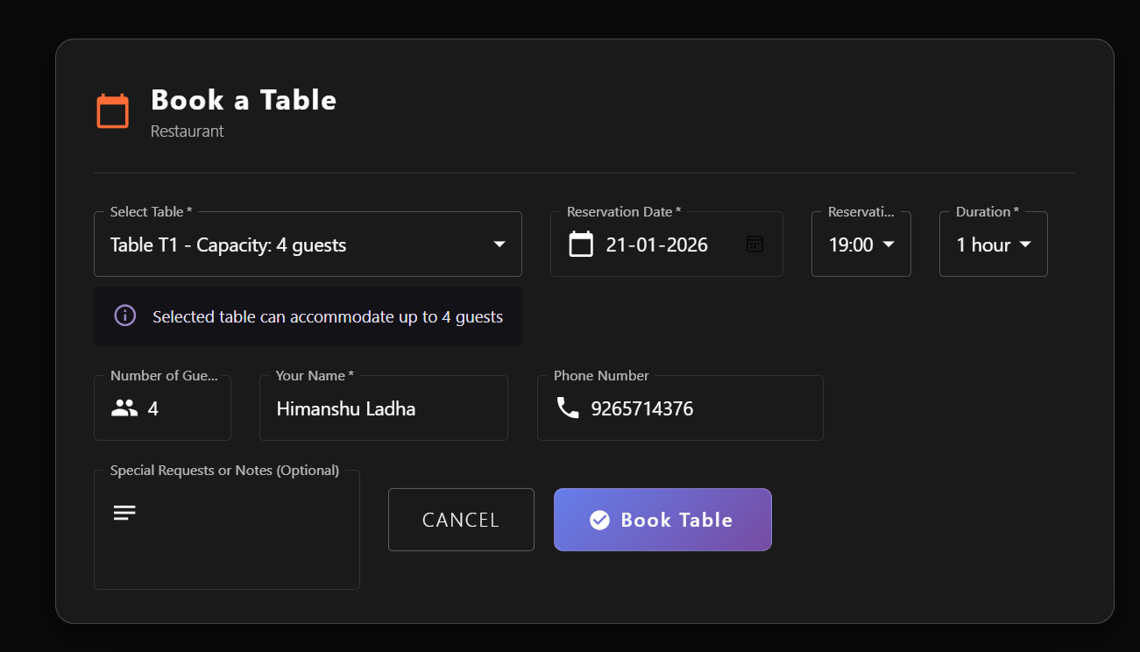
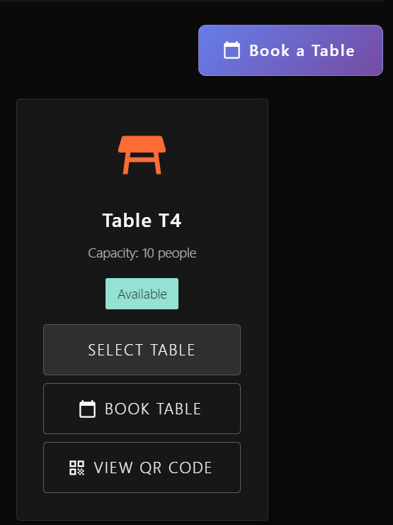
- Added the reservation system in the project where they can reserve the table for the order.
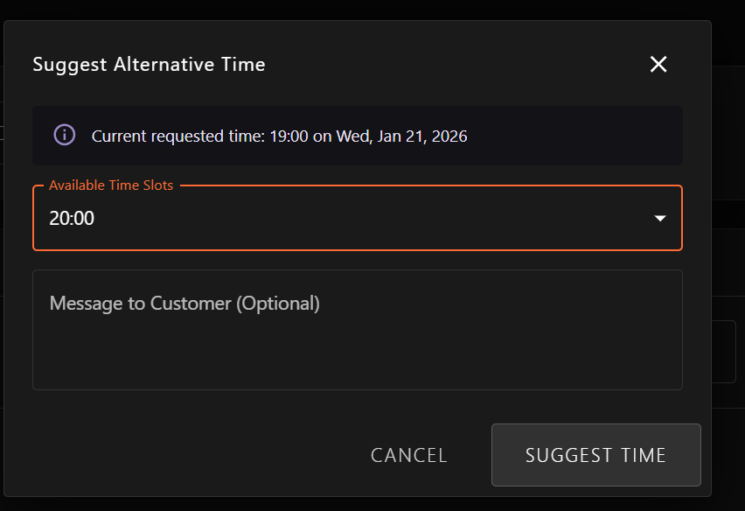
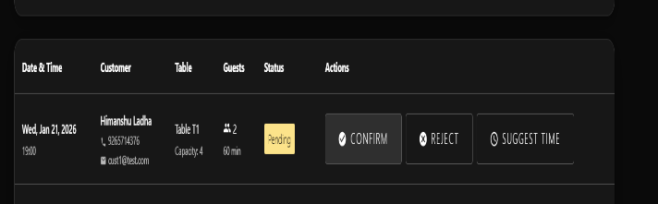

- From the book table they can book the table and fill the details accordingly.
- And then Restaurant admin will confirm the reservation with the suggest time if not possible on there time.
- And after confirming the reservation then the customer then will come and restaurant admin will mark arrive and then customer can place the order from that place and the continue the flow of order.
21-01-2026
- Continue the remaining procedure of the backend in restaurant admin side.
- Added the process of the flow of the reservation system.
- Design the remaining process of the system.
22-01-2026
- Continued the implementation of the reservation system in the restaurant admin side first.
- And checked the admin side with various procedure that is fully featured or not.
23-01-2026
- At the end of the implemented the process of the system in the customer side.
- Checked the process of implementation.

